*&---------------------------------------------------------------------*

*& Report zyny_select_demo_01

*&---------------------------------------------------------------------*

*&

*&---------------------------------------------------------------------*

REPORT zyny_select_demo_01.

"OLD METHOD

*TYPES: BEGIN OF STR,

* CARRID TYPE SPFLI-CARRID,

* CONNID TYPE SPFLI-CONNID,

* CITYFROM TYPE SPFLI-CITYFROM,

* CITYTO TYPE SPFLI-CITYTO,

* END OF STR.

*

*DATA: ITAB TYPE TABLE OF STR,

* WA TYPE STR.

*

* SELECT

* CARRID

* CONNID

* CITYFROM

* CITYTO

* FROM SPFLI

* INTO TABLE ITAB.

*

*LOOP AT ITAB INTO WA.

* WRITE:/ WA-CARRID, WA-CONNID, WA-CITYFROM, WA-CITYTO.

* ENDLOOP.

"NEW METHOD

SELECT

CARRID,

CONNID,

CITYFROM,

CITYTO

FROM SPFLI

INTO TABLE @DATA(ITAB).

LOOP AT ITAB INTO DATA(WA).

WRITE:/ WA-CARRID, WA-CONNID, WA-CITYFROM, WA-CITYTO.

ENDLOOP.

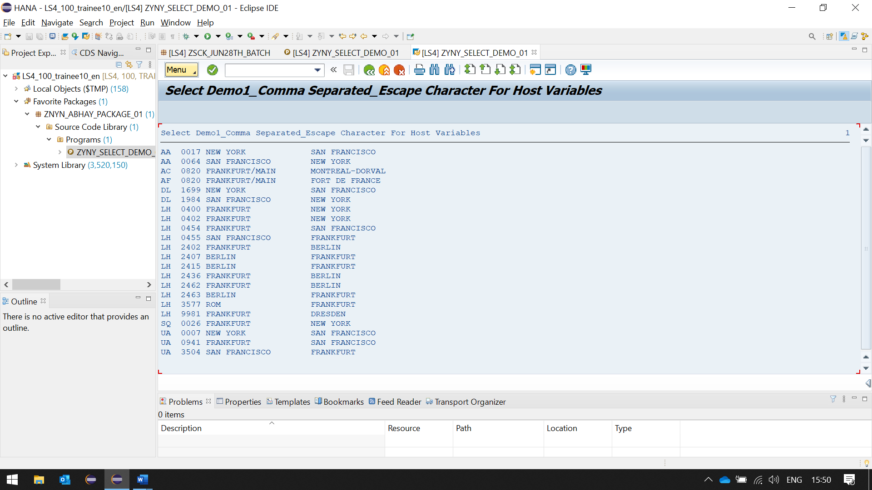

HERE WE DOES NOT NEED TO CREATE INTERNAL TABLE IMPLICITLY, IT WILL BE CREATED IN RUN TIME